RamArts Billing Software Noted Updates!!

Q. If I ever do changes in the application I just have to update the files in the github and wait for successfully it's integration and then the changes will be done in the application in both desktop and mobile is it?
Yes, exactly! But there is **one small rule** you must follow to make sure the app actually "notices" the update.

### **The "Golden Rule" for Updating PWAs:**
Whenever you change your HTML, CSS, or JS files, you **must** also update the version number in your [service-worker.js](file:///c:/Users/HP/OneDrive/Documents/Desktop/RamArts%20Billing/service-worker.js).

**Here is the exact workflow for any future changes:**

1. **Edit your code**: Make changes to [index.html](file:///c:/Users/HP/OneDrive/Documents/Desktop/RamArts%20Billing/index.html) or any other file.
2. **Update the Version**: Open [service-worker.js](file:///c:/Users/HP/OneDrive/Documents/Desktop/RamArts%20Billing/service-worker.js) and change the `CACHE_NAME` (e.g., from `ramarts-v6` to `ramarts-v7`).
- *If you don't do this, the phone will keep showing the old version from its memory.*
3. **Upload to GitHub**: Upload all changed files (including the service worker) to your repository.
4. **Wait for GitHub**: Give it 1 minute for the GitHub "Integration" (deployment) to finish.
5. **Open the App**:
- Open the app on your mobile or desktop.
- **Close and reopen it twice**.
- The first time you open it, the browser "sees" the new service worker and downloads the update in the background.
- The second time you open it, the new version is activated and shown to you.

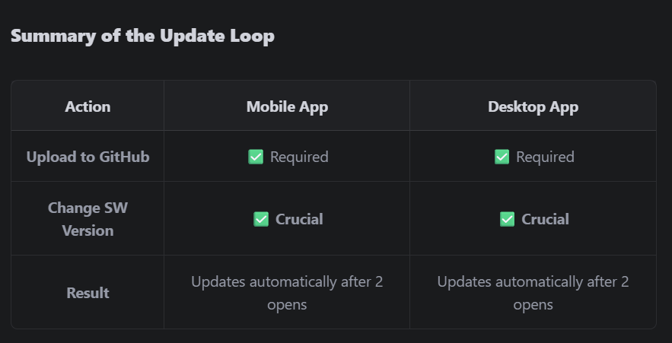

You're all set! Your billing system is now a professional-grade, installable, and easy-to-update application. Is there anything else you need help with?

** If updates not visible after this **
- Update the edited files in GitHub.
- Uninstall the application without clearing the data.
- Re-visit the link and Install the application.
- See the changes will seen updated.

